Kusudama Therapy in Loughborough

My office is inside the Ark Business Centre on Gordon Road, off of Station Boulevard.
I am on the 1st floor, Unit 12 inside the main building.
The address and postcode are:
Unit 12 Ark Business Centre
Gordon Road
Loughborough
LE11 1JP

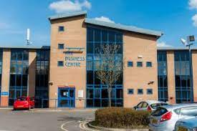
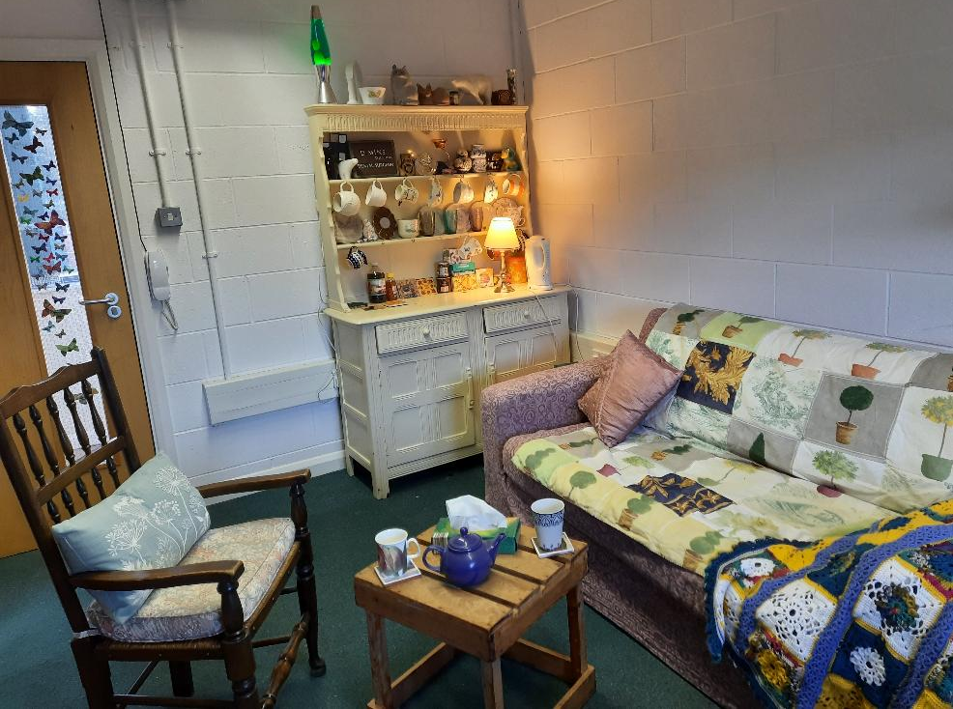

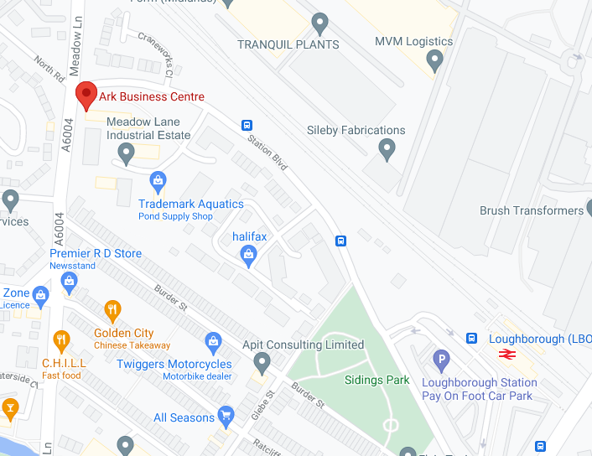
Getting here
My office is a short walk from Loughborough train station.
The bus routes 1, 8, 9, 27 and Sprint all stop nearby.

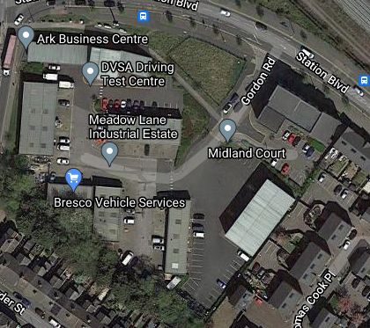
Visitor car park
Disabled parking
Parking
There is a large visitor car park on the entrance to the industrial estate, and limited disabled parking just outside the building.

On arrival
Feel free to wait inside in either the lobby or the reception area if open. I will come down and meet you just before your scheduled appointment time and show you up to my office.
Please do not ring my bell or text me more than 5 mins before your scheduled session, as I will not be able to answer when I am with other clients.
Accessibility
The building is fully accessible, with ramps and a lift as well as disabled toilets. The external door is quite heavy, so please ask if you would like help getting into the building. There is room in my office for a wheel chair.

Covid regulations
At present there are no specific Covid-19 regulations required for users of the building. I am testing regularly and have been vaccinated, but you need to be aware that other users of the building may not have been. It is your choice if you wish to wear a mask in the general areas. The room itself will be cleaned and well ventilated between clients, and the window will remain open during sessions. You may wish to bring extra layers when it is cold.
If you have specific questions or concerns about this or other potential risk with visiting my office, then please let me know so we can think about how to meet your needs. A copy of my Covid risk assessment is available on my website.

I look forward to welcoming you to my office soon.

